**PIZZA SALE SQL QUERIES**

1. **KPI’S**
2. TOTAL REVENUE

**SELECT SUM(total_price) AS Total_Revenue FROM pizza_sales**

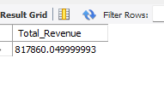

1. Average order value

select sum(total_price)/ count(distinct order_id) as avg_order

from pizza_sales

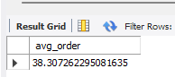

1. Total Pizza Sold

select sum(quantity) as Total_pizza_sold

from pizza_sales

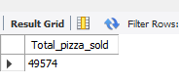

1. Total Orders

select count( distinct order_id) AS Total_order FROM pizza_sales

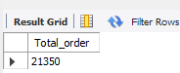

1. Average Pizza Per Order

SELECT CAST(CAST(SUM(quantity) AS DECIMAL(10,2)) /

CAST(COUNT(distinct order_id) AS DECIMAL(10,2)) AS DECIMAL(10,2)) AS avg_pizza_per_order FROM pizza_sales

